Sittercise Training

2401 Windy Hill Rd # 2415

S. Marietta, GA 30067

Tel: 800-470-3407

Fax: 678-825-3946

Local: 404-642-5649

Contact: Tyree Blake

Email:

[sittercisetraining@gmail.com](mailto:sittercisetraining@gmail.com)

Web address:

[www.sittercisetraining.com](http://www.sittercisetraining.com)

[www.maintaininglifehealthfitmess.com](http://www.maintaininglifehealthfitmess.com)

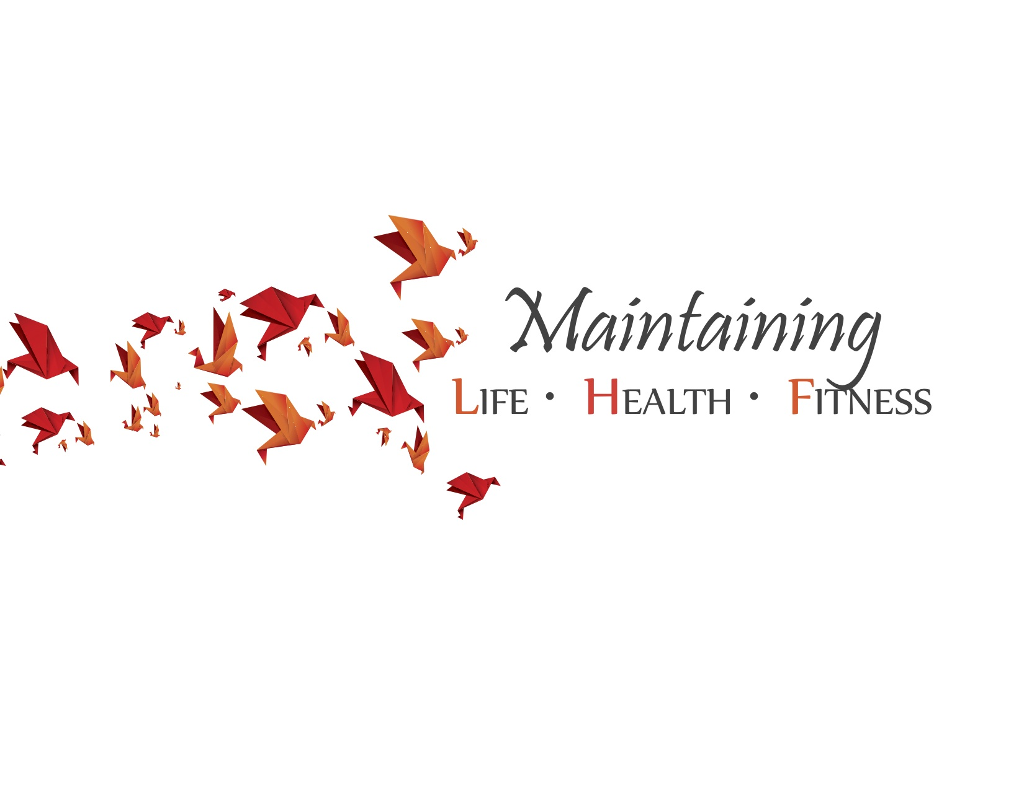

# Course Schedule

9-11 Basic Anatomy/Muscle Activity

11:10-12:00 Bio Mechanics/Motor Control and Learning

12:00-12:30 Lunch

12:30-2:00 Weight Management/

Exercise for health and fitness/

Challenges of aging

2:00-2:10 Break

2:10-3:30 Vital Signs/CVA/Dementia/

Mental Health Older Adults/

Sittecise Program

3:30-5:30 Practical/Written Exam

Breaks are 10 minutes in duration.

#### Instructor Bio

Randall S. Watkins, DrPH, MS, OTR/L, ATC, NSCA-CPT, STSP

Hello and welcome. My name is Dr. Randall Watkins and I am the Vice President of Maintaining Life, Health, & Fitness. Here is a brief synopsis of who I am from a professional perspective. I currently possess a Doctoral degree in public health (DrPH), Master’s degree in occupational therapy (OT); I have two Bachelor’s degrees in exercise science and athletic training, as well as a minor in business administration. I am a registered and licensed occupational therapist, a certified athletic trainer (ATC), as well as a certified personal trainer through the National Strength and Conditioning Association (NSCA). I have owned a private outpatient physical rehabilitation clinic, worked in a variety of healthcare environments (e.g. hospital, outpatient, and homecare), and have collaborated with many healthcare professionals in establishing a program for those individuals who suffer from obesity. I have had the pleasure of working with clients/patients from pediatric to geriatric in a variety of health care settings. I am a published author and the title of my book is the Human Mechanic. Furthermore, I teach two health courses. These courses are titled “Health care in the US” and “Wellness in a Diverse Society”.

***Maintaining***

**LIFE * HEALTH* FITNESS**



*“Living Life to Its fullest”*

*“Success is the journey not the destination”*

[www.sittercisetraining.com](http://www.sittercisetraining.com)

Course Information:

● 8 hour course

● 30 minute lunch break

● Earn 8 CEU credits

● Certified in Sittercise Training

The course provides:

● Sittercise Training workbook

● CEU Completion Certificate

● Sittercise fitness DVD

● Course Fee: $500/person

● Group Fee: $375/person

(7+/group)

● College Students: $325/person

# Sittercise Training CEU Course Summary

Sittercise is a program and concept with the intent to improve and or abate further health decline. The concept is to be focused on providing the client and caregiver the necessary tools to improve one’s quality and quantity of life. Sittercise is a means to coexist with aging in place ideal, caring for one’s self (ADL’s/IADL’s), daily functional activity, and overall improved function (strength, balance, stability, and endurance). Sittercise is a means to decrease the hospital recidivism rate. Sittercise training is and educational tool that can be utilized to improve one’s knowledge of their illness or condition, as well as provide the tools to alter their overall sense of wellness and health.

# Course Descriptions

# This course provides a global approach to the concept of health, wellness and fitness, as it relates to the older adult populations. This course will allow fitness professionals to obtain a base level of anatomy, while addressing concepts of motor learning, biomechanics, eating disorders, weight management, mental health related concerns, and the Sittercise program. This program will provide professionals an understanding of how to address the fitness concerns of the older adult population, while considering physical concerns such as hip replacement, residual effects of a stroke, and various types of precautions which can be specific to this population. This is a holistic program to assist with clients in a post-acute setting in the home environment or in an environment which is conducive to one’s client population.

# Course Objectives

1 .At the conclusion of this course, participants will review and or learn basic anatomical structures and functions necessary for exercise program assessment, development, and adjustment.

2. After to completing this class, participants will have an improved understanding of health related concerns of this specific population such as dementia, mental illness, and physical impairments.

3. At the conclusion of this course, participants will understand how to prescribe exercise programs, safely and adapt program to the needs of the client.

4. After the completion of this course, participants will learn how to provide safety cues, verbal and or tactile, in order for successful completion of the Sittercise Training program.

5. At the end of the course, participants will be able to demonstrate the ability to explain and determine muscle actions and functions.

#### Sittercise CEU Training Course

